## Day Three/Wednesday October 16 : Routines for Increased Communication

Empower your student with independence and communication! Calendars can serve many functions regarding the development of time concepts and language acquisition. A calendar can function as a timepiece providing structure to the days events, as well as providing a static form of communication that can be referred to beyond the context of the current moment. Calendars can also give opportunities for social interaction by providing topics for conversation.

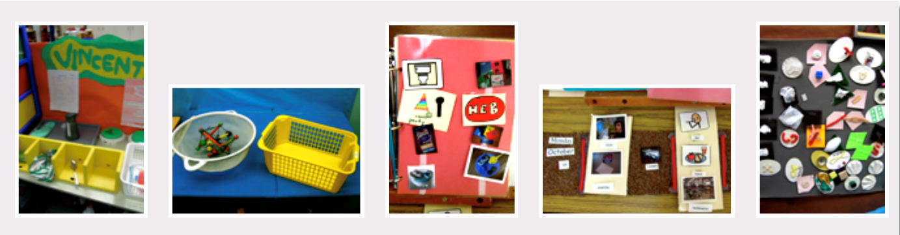

8:30-9:00 Introduction & Housekeeping

9:00 Calendars

Why Routines

Activity: Think About a Routine/Opportunity for Making Choices

10:30 Break

Principles of Communication

Name cues/symbols

Where Do I Start?

Activity: Early Tactile Learning Profile

Activity: Let’s Do This

Guide to Selecting Time Frames

11:30 Lunch

12:15 Types of Calendars

Anticipation

Daily

Weekly

Two Week

Monthly and Annual

1:30 Activity: Let’s Talk

1:45 Assistive Technologies for Calendar and Routine Management

1:30 Recap/Powerful Tool

1:45 Q&A Session /Evaluation------

2:00-3:30 Create Calendars-Make and Take

**Thank you for coming! See You Next Year!**